Year | Expenditure (In Cr Rs) | No of Electors | Expenditure per elector (In Rs) | Polling Station
1952 | 10.45 | 17,32,12,343 | 0.6 | 1,96,084
1957 | 5.9 | 19,36,52,179 | 0.3 | 2,20,478
1962 | 7.32 | 21,63,61,569 | 0.3 | 2,38,031
1967 | 10.8 | 25,02,07,401 | 0.4 | 2,43,693
1971 | 11.61 | 27,41,89,132 | 0.4 | 3,42,918
1977 | 23.04 | 32,11,74,327 | 0.7 | 3,73,910
1980 | 54.77 | 35,62,05,329 | 1.5 | 4,36,813
1984-85 $ | 81.51 | 40,03,75,333 | 2 | 5,06,058
1989 | 154.22 | 49,89,06,129 | 3.1 | 5,80,798
1991-92 # | 359.1 | 5,11,533,598 | 7 | 5,91,020 *
1996 | 597.34 | 59,25,72,288 | 10 | 7,67,462
1998 | 666.22 | 60,58,80,192 | 11 | 7,73,494
1999 | 947.68 | 61,95,36,847 | 15 | 7,74,651
2004 | 1113.88 | 67,14,87,930 | 17 | 6,87,402
2009 | 846.67 | 71,69,85,101 | 12 | 8,30,866
* Excludes J&K in 1991-92
1989 to 2009 General Elections’ Expenditure figures are provisional
$ Elections were held separately for States of Assam & Punjab in 1985
# Elections were held separately for State of Punjab in 1992
(Source: Ministry of Law and Social Justice & ECI website)

 Election Expenditure 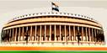 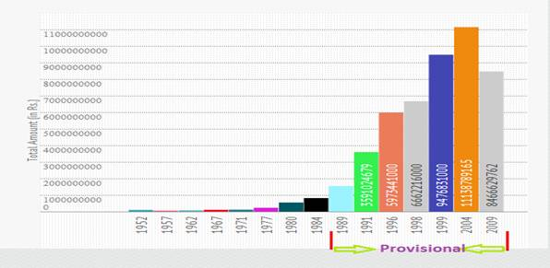

***

Source: Election Commission of India

